**Issue No: 24**

**Issue: PO tax missed issue**

**Details:**

**Issue IMG:**

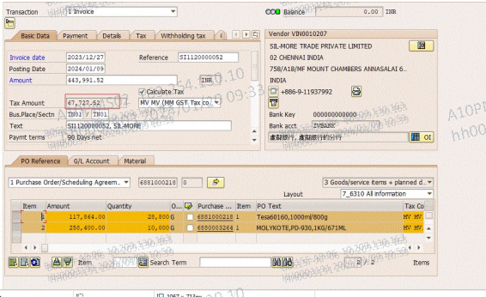

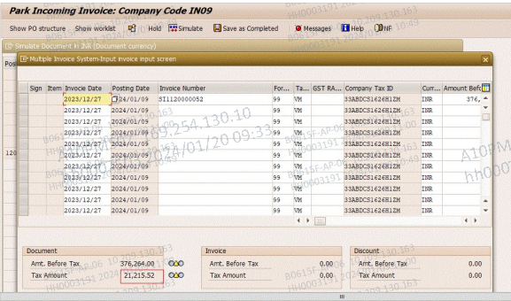

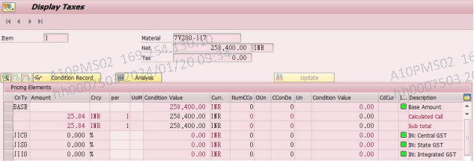

**Conclusion:**

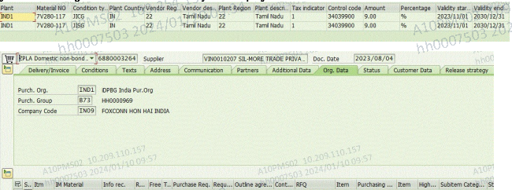



**Issue No: 29**

**Issue: HH0002762, 1164, 2742, 3022, 8119 SAP ID INDPP01 cost location ( M1PF, M7PF, N2PF ) not showing**

**Details:**

**DB: ZIDPMM016:**

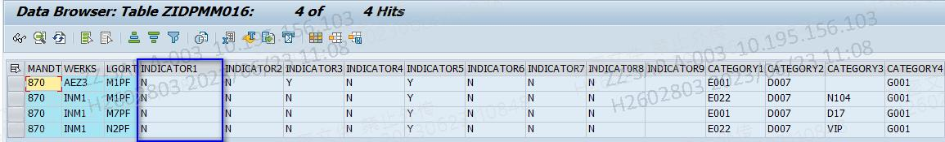

**Conclusion:**

**Only CM team can change the location type. In why IT cannot define the location belong to cost or no cost.**

**Issue No: 30**

**Issue: Mentioned PO numbers 6890012727,6890012733,6890012734,6890012751,6890012752 post in SAP also reflect in i-Pocket but unable to grab against MRP version.**

**Details:**

**Issue IMG:**

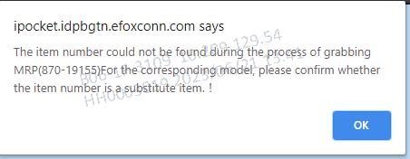

**RFC run data ZRFC_PP_IDP_0162:**

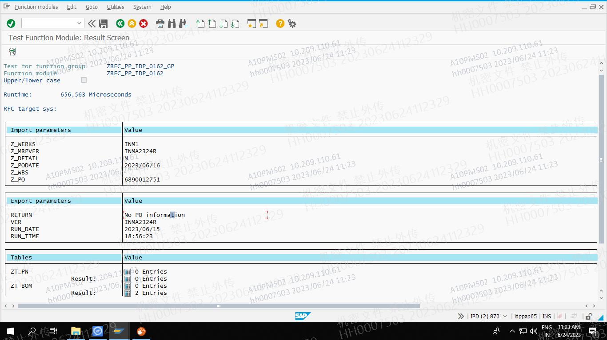

**Route cause:** MRP version not maintained two materials

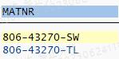

**Conclusion:**

**Not cleared this issue.**

**Issue No: 31**

**Issue: 2317000245, 2317000246,2317000247 this all Production order is released but not posted.**

**Details:**

**Issue IMG:**

**CO05N check the system status CRTD CNC MANC SETC it is status for not released**

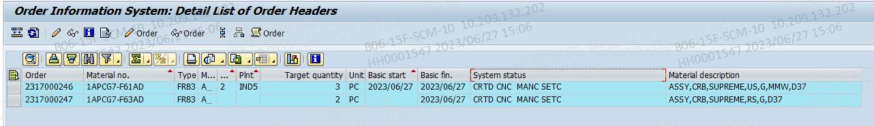

**Use CO02 to release click green flag icon to release: This is already released image**

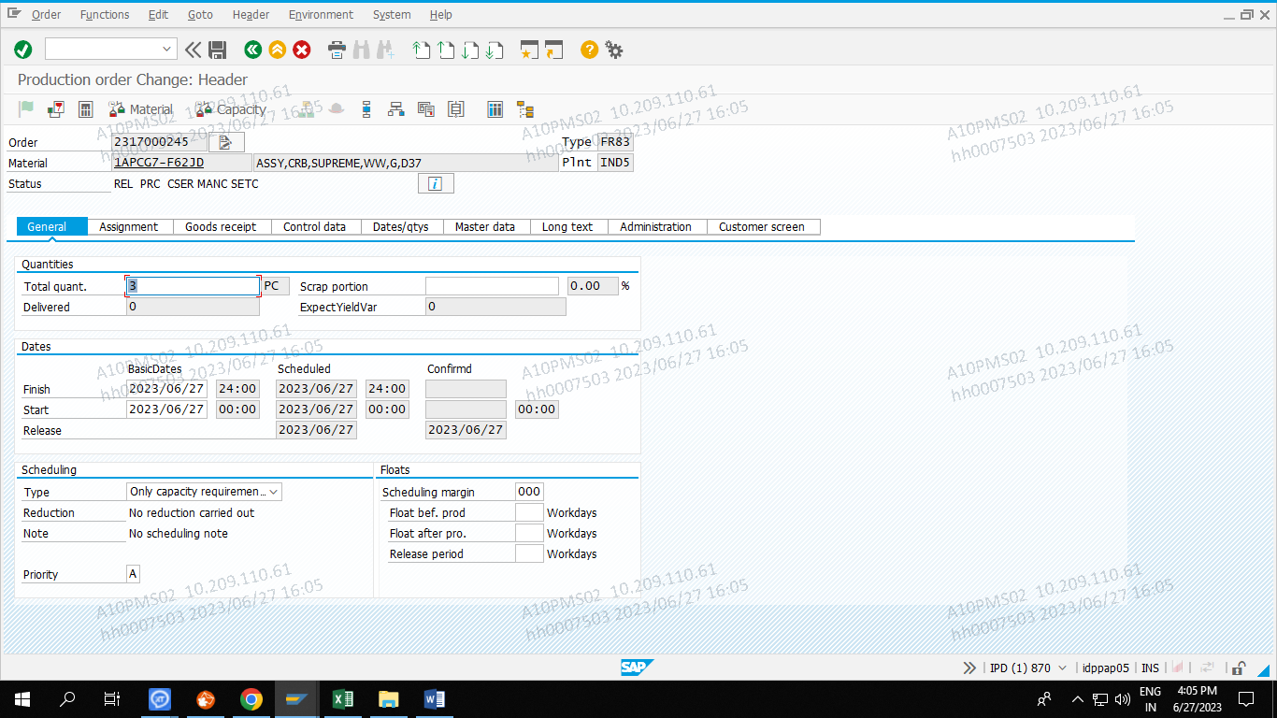

**Conclusion: See the status it is released status**

